**Overview of UM University Bookstore App**

Introduction:

In today's digital age, UMbookstore app to cater to the needs of its students and faculty. This app offers a seamless online book-shopping experience, ensuring that users can effortlessly search, purchase, share, and rate books.

**Storyboard Overview:**

**1. Book Search:**

The primary page of the application prominently features a search bar for easy book discovery. Users, like Rob in our scenario, can comfortably log into their accounts, guaranteeing a personalized shopping experience. Upon entering a search term, the system swiftly displays relevant results, guiding users to their desired books.

**2. Cart and Checkout:**

Upon identifying their preferred books, users can effortlessly add them to their shopping cart. Subsequently, the app navigates the users to the checkout page, summarizing the cart's contents and the total amount due. The checkout process is secure, offering multiple payment options for users to select from. Once the payment is made, a confirmation of the successful transaction is provided.

**3. Sharing and Rating:**

Post-purchase, the app allows users to rate and share their acquisitions. Users can swiftly navigate to their personal book list, observing their purchase history and browsing records. Additionally, the app includes a sharing feature, enabling users like Rob to recommend their favorite books to friends, as he did with Jack.

**Operational Mechanism:**

The Bookstore app of UM University places a premium on user experience. The login and registration processes are straightforward, facilitating easy access for both new and returning users. Once logged in, the personal dashboard of the user becomes the nucleus of all book-related activities. The checkout mechanism is designed to offer the utmost convenience, with explicit item descriptions and real-time price calculations simplifying the purchasing procedure.

**Conclusion:**

UM University's Bookstore app revolutionizes the way students and faculty engage with their reading materials. By marrying a user-friendly interface with robust functionalities, it promises an unparalleled book-shopping experience.

**Storyboard 1: Searching for a Book**

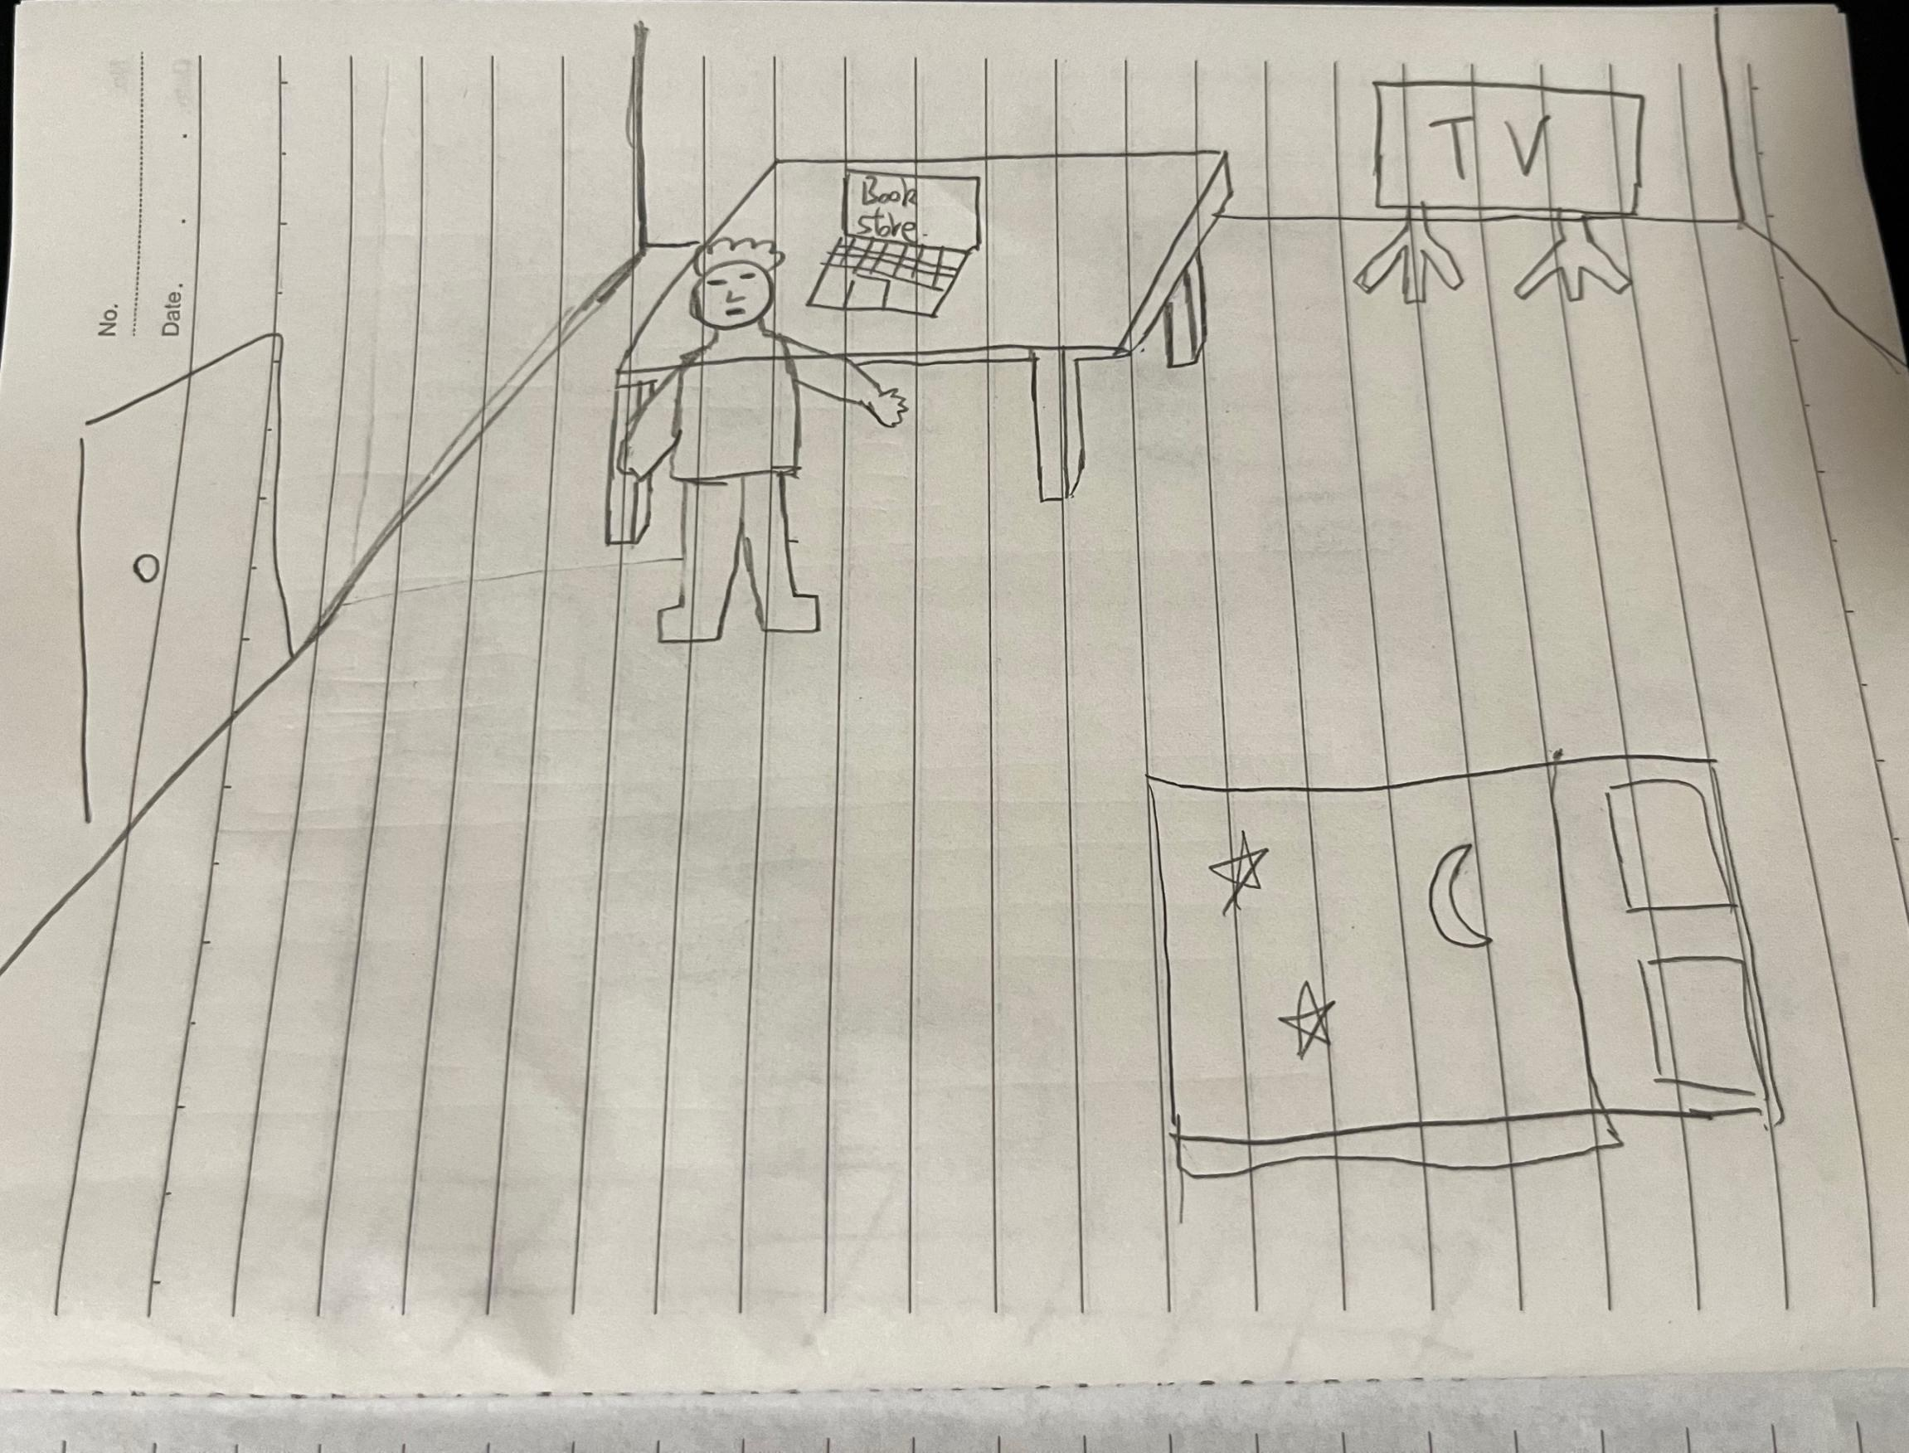

1. Robert decides to use the Bookstore App to purchase the materials required for the current semester.

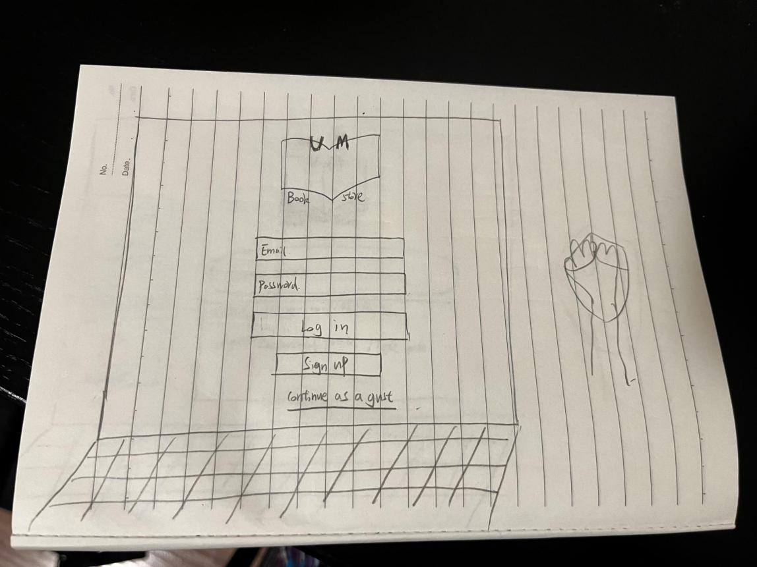

1. Scene: Rob arrives at the online bookstore's homepage.

Description: The website's clean layout welcomes Rob, prominently featuring a search bar for easy access.

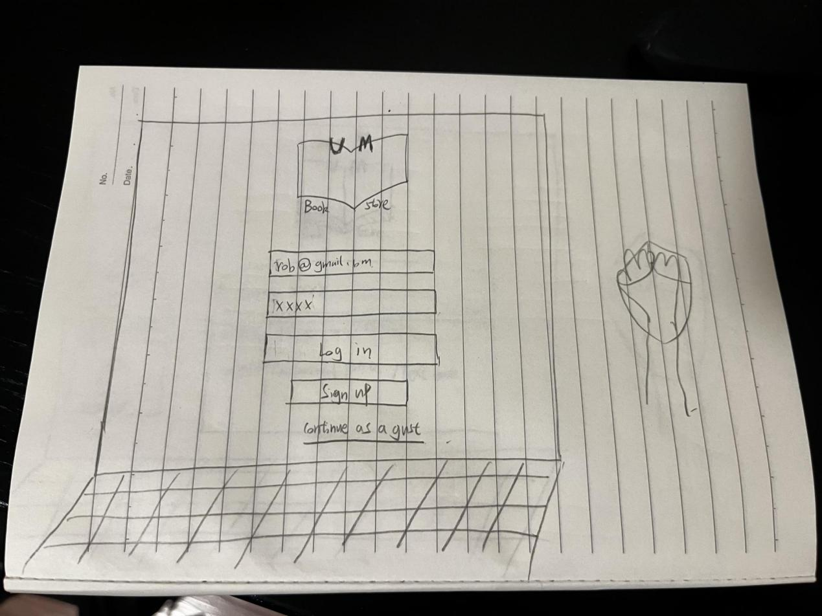

1. Scene: Rob logs into his account.

Description: The login page is straightforward, and Rob quickly inputs his credentials to access his personal dashboard.

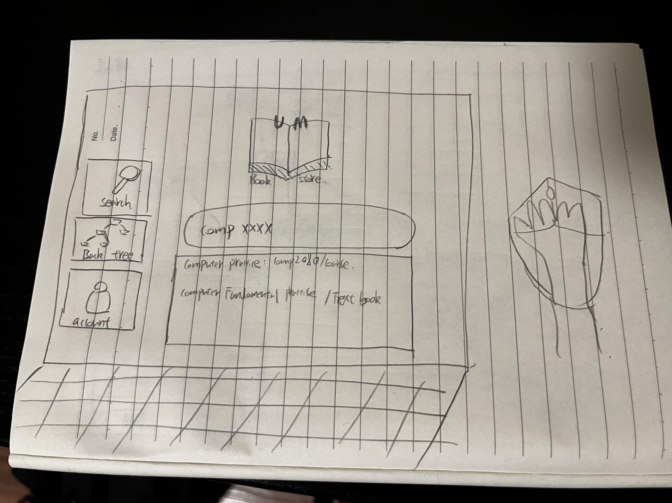

1. Scene: Rob begins his search.

Description: Rob types a query into the search bar, hoping to find a specific book.

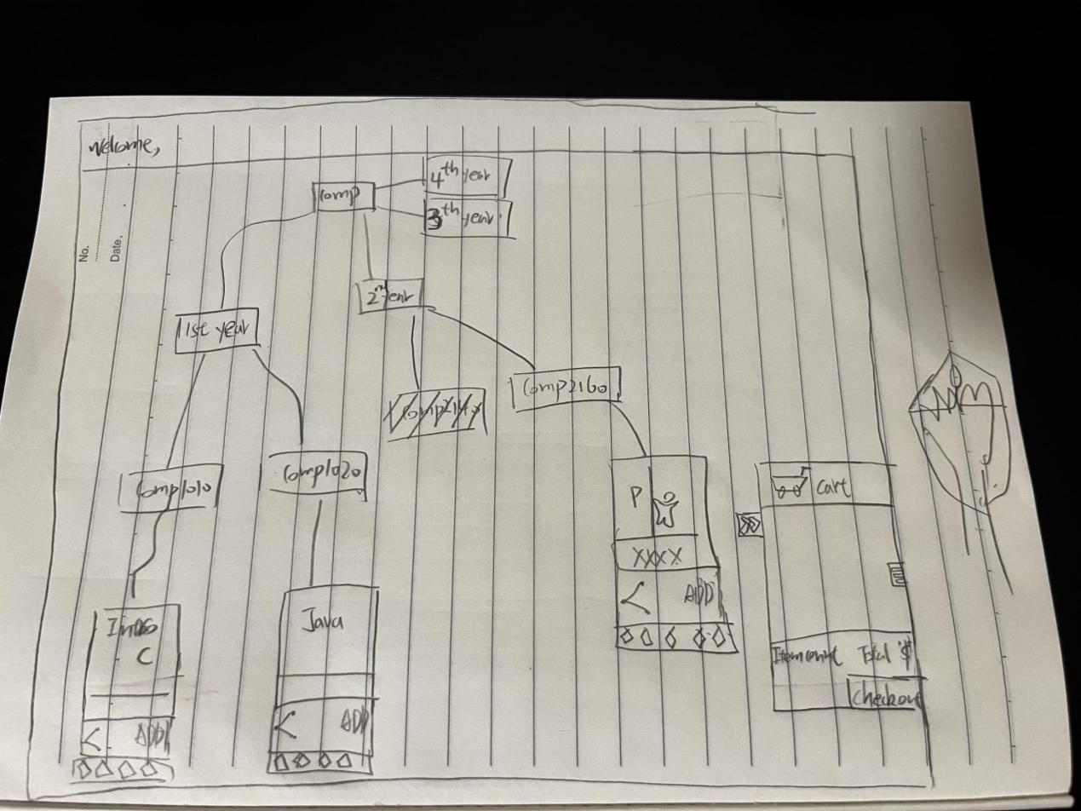

1. Scene: The website displays the search results.

Description: A structured tree of books pops up, guiding Rob to the exact book he needs.

**Storyboard 2: Cart & Checkout**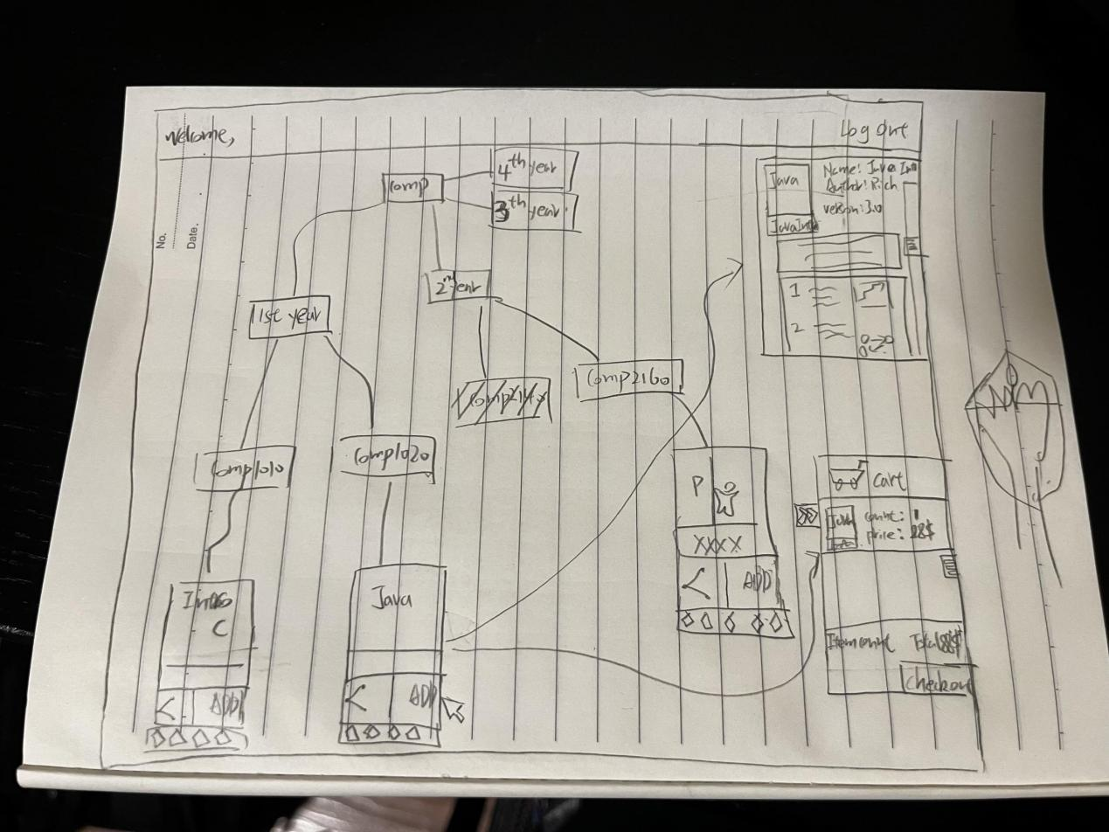

1. Scene: Rob adds his desired book to the cart.

Description: With a simple click, the book seamlessly transfers to Rob's virtual cart.

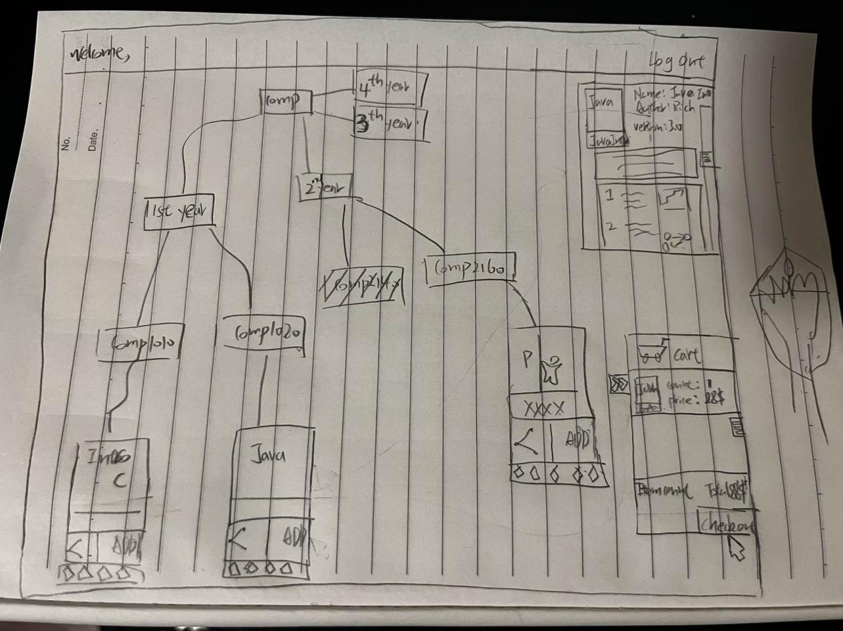

1. Scene: Proceeding to checkout.

Description: Rob, confident with his choice, clicks the "Check Out" button.

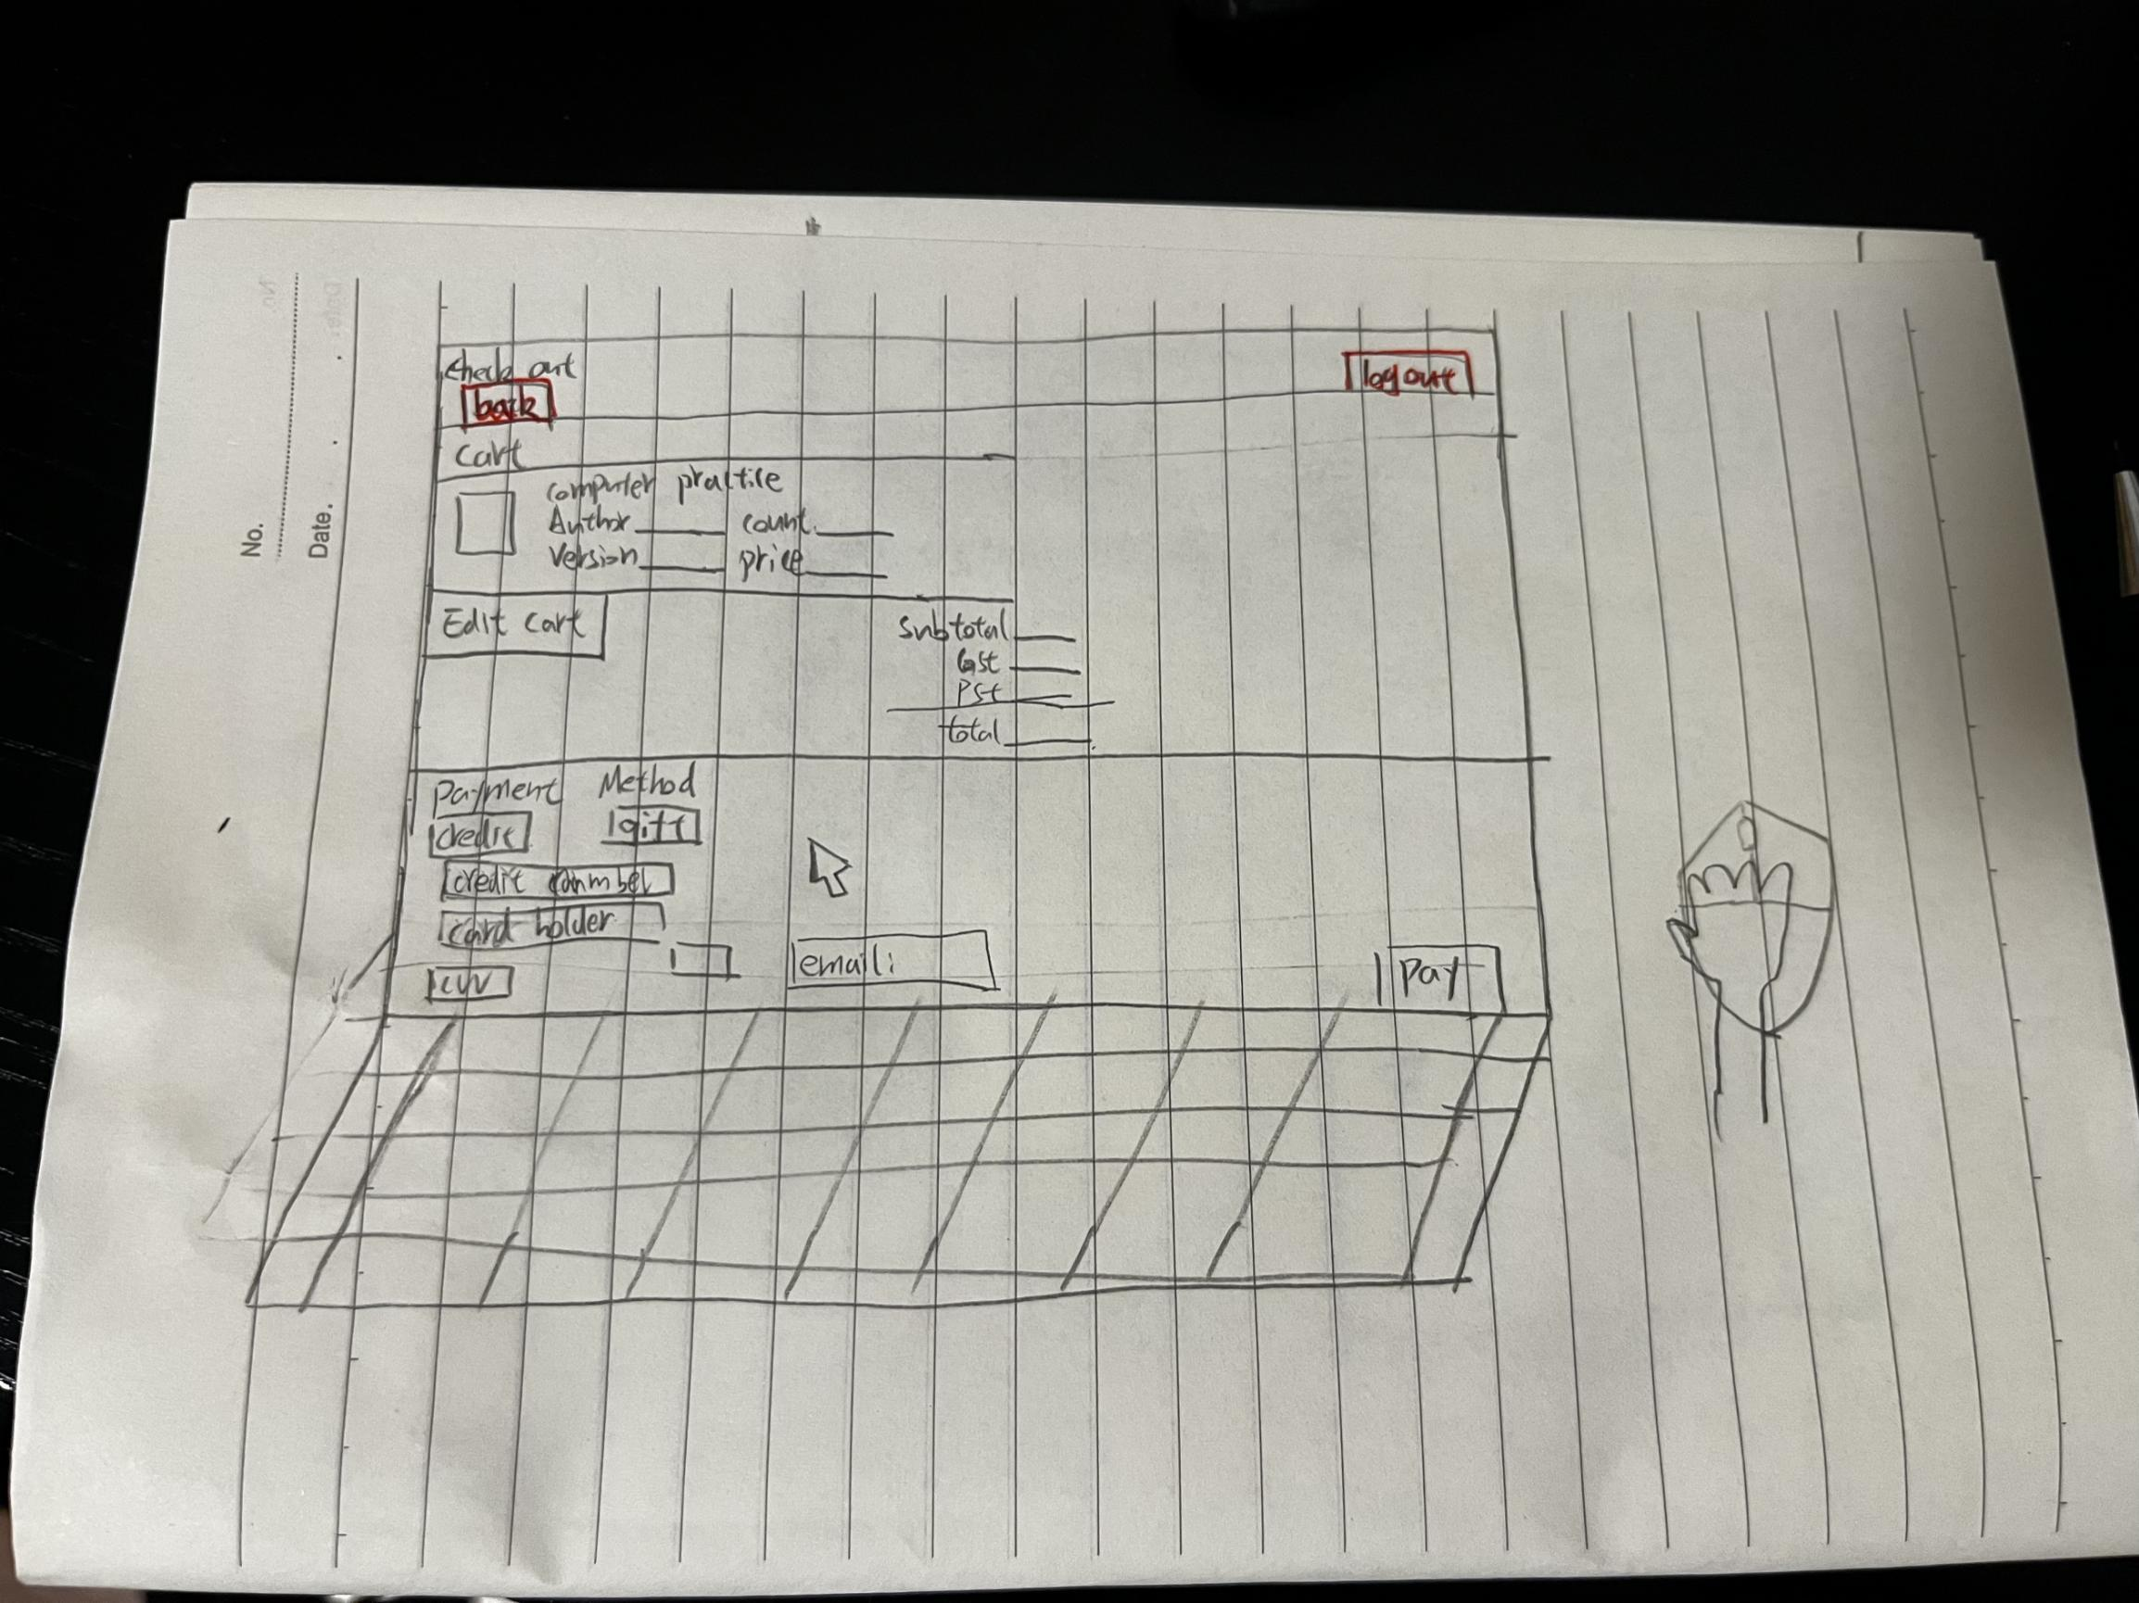

1. Scene: The checkout process begins.

Description: Rob is presented with a summary of his cart and the total price.

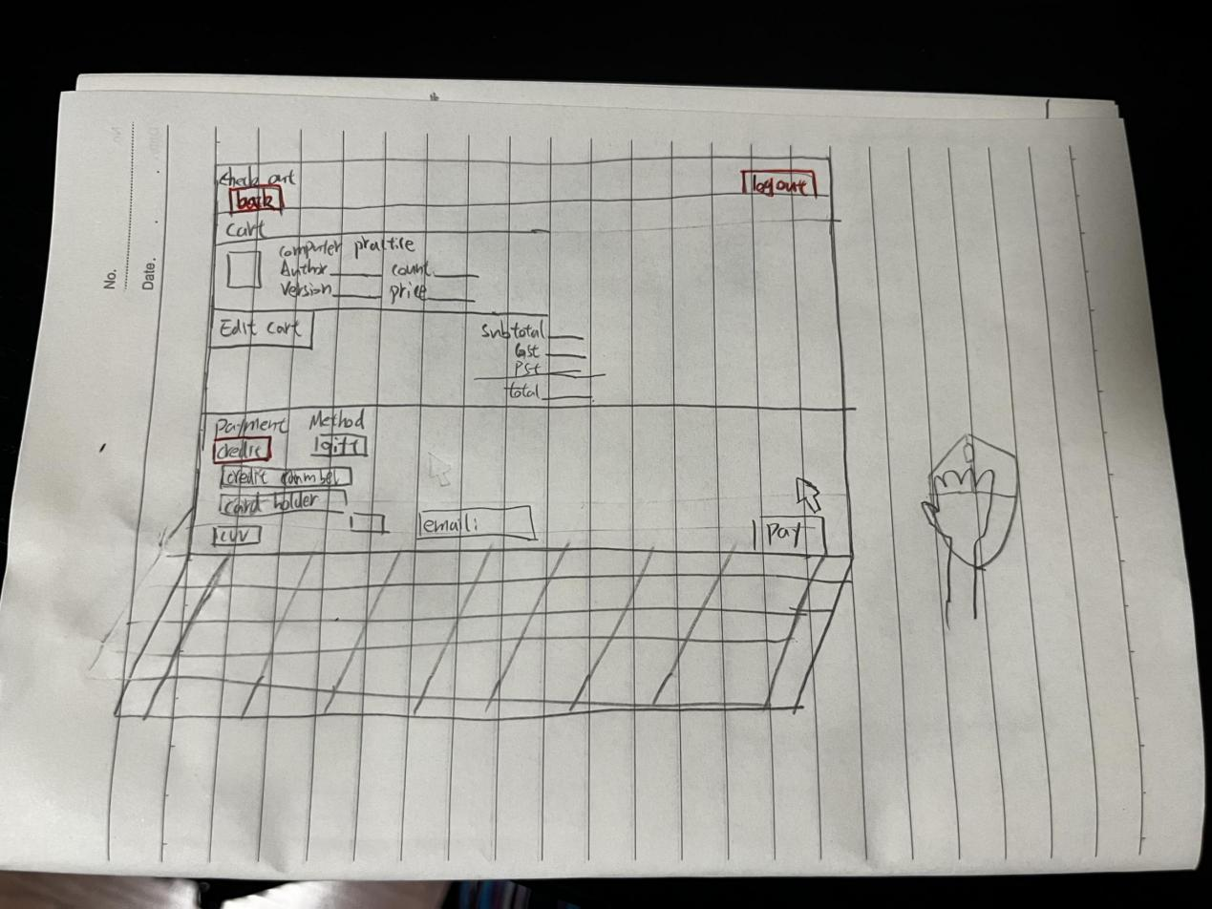

1. Scene: Payment selection and completion.

Description: Rob chooses his preferred payment method, enters the required details, and confirms the purchase.

**Storyboard 3: Sharing and Rating**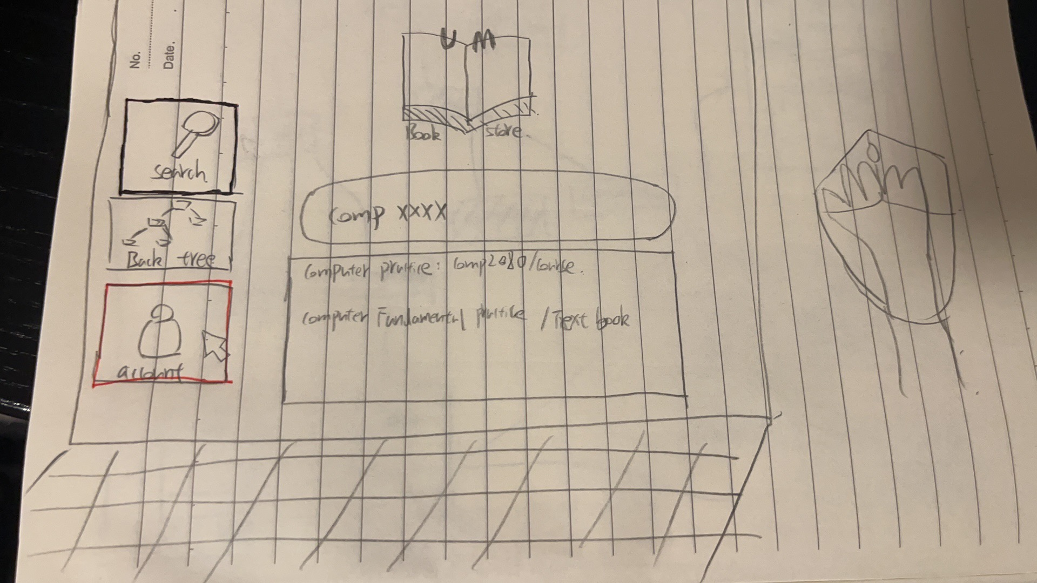

1. Scene: Rob's return to the website.

Description: Upon revisiting the website, Rob is automatically directed to the search screen.

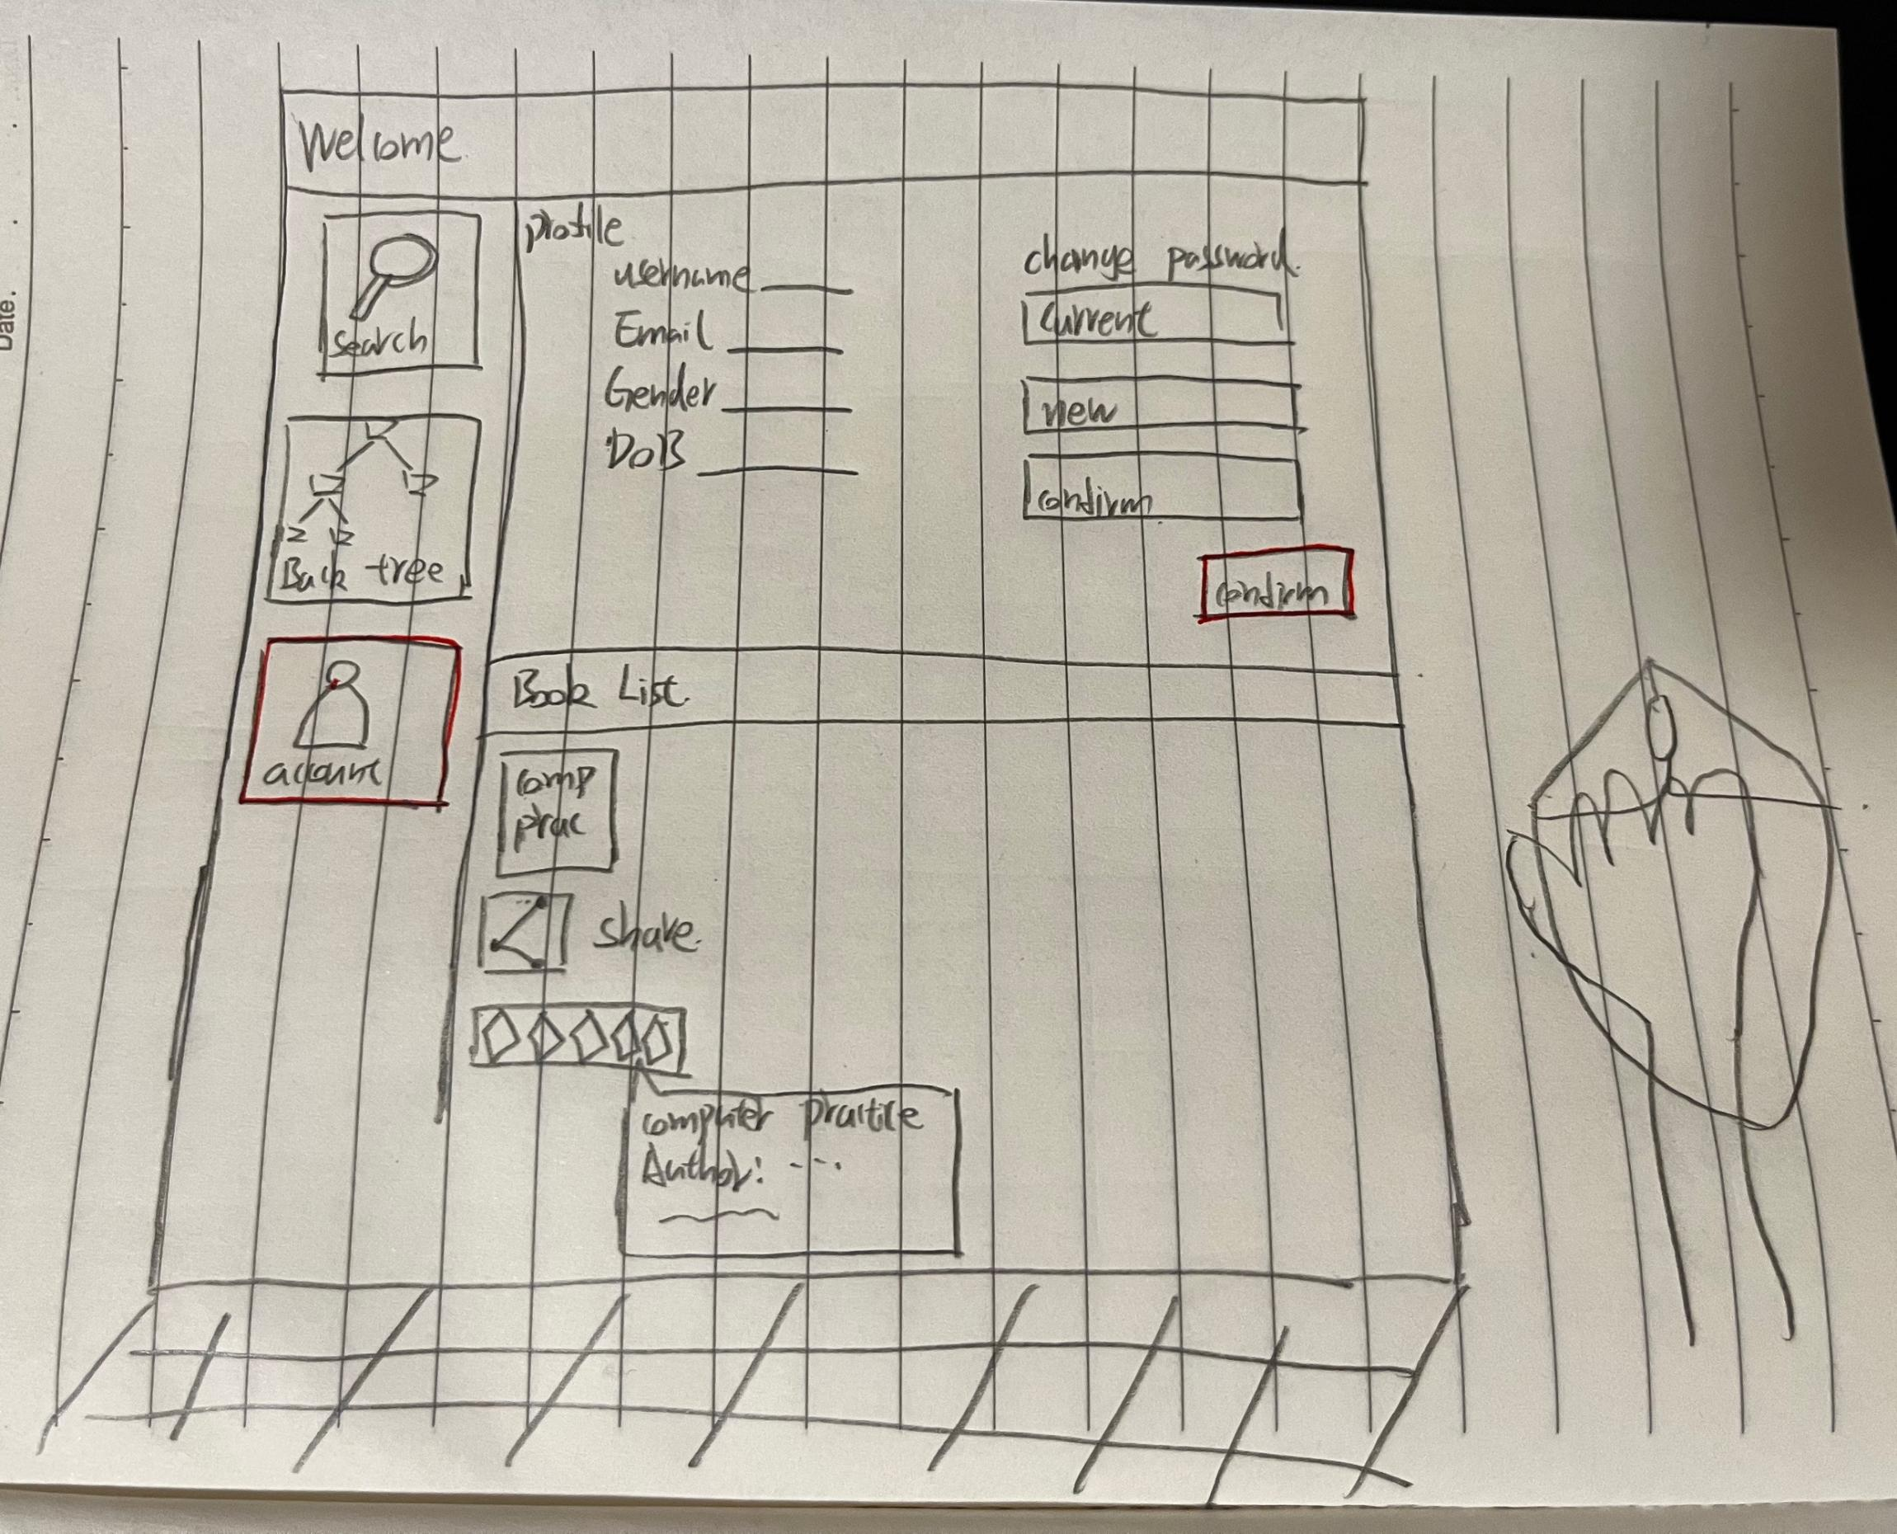

1. Scene: Accessing personal book list.

Description: Rob clicks on his account, viewing his personal list of purchased and browsed books.

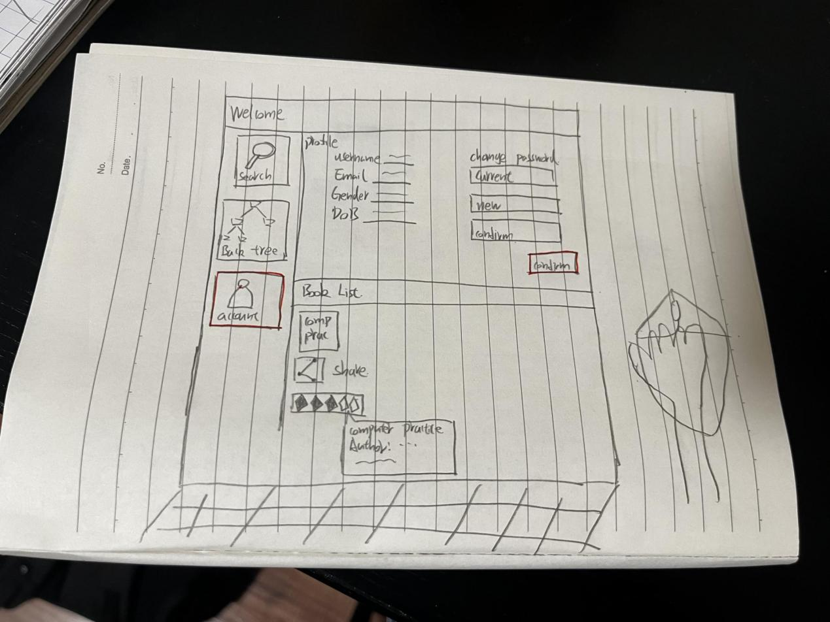

1. Scene: Rating his recent purchase.

Description: Seeing the book he just bought, Rob clicks on the star icon, rating it based on his experience.

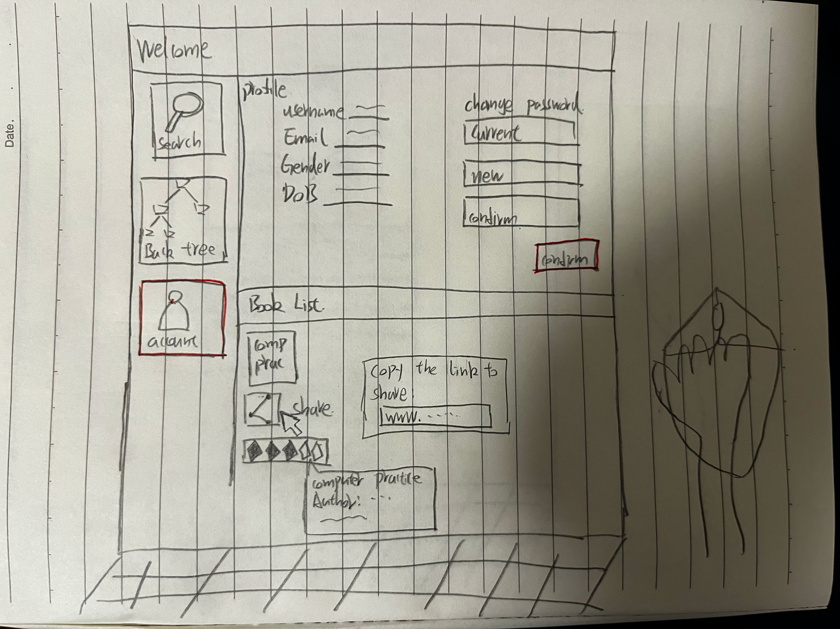

1. Scene: Sharing the joy of reading.

Description: Rob decides to recommend the book to Jack. He clicks "Share," sending a notification to Jack about the book.